**Using/creating Dockerfile and Compose – from Travelmemory App**

**1.Create EC3 instance -linux**

**2.Connect the instance and install all necessary files**

**sudo su -**

* **yum update -y**
* **yum install docker**
* **systemctl start docker**
* **systemctl enable docker**
* **yum install git**

**3.Clone the repo**

* **git clone** [**https://github.com/Kavi1312/TravelMemory.git**](https://github.com/Kavi1312/TravelMemory.git)

**4. Navigate to folder**

* **cd Travelmemory/backend**

|  |
| --- |
|  |
| **5. Create Dockerfile** |
| * **Vi Dockerfile** |
|  |
| FROM ubuntu:latest |
| WORKDIR /app |
| COPY . /app |
| RUN apt-get update && apt-get install -y nodejs npm git && npm install |
| EXPOSE 3000 |
| CMD ["node", "index.js"] |

**Esc - save and exit**

**:wq**

FROM ubuntu:latest

# Set the working directory inside the container

WORKDIR /app

# Copy the rest of the application files

COPY . /app

# Install Node.js, npm, and all dependencies listed

RUN apt-get update && apt-get install -y nodejs npm git && npm install

# Expose the application port

EXPOSE 3000

# Start the application

CMD ["node", "index.js"]

**Why is Each Step Important?**

| **Instruction** | **Why It's Used** |
| --- | --- |
| **FROM** | **Defines the base image to build upon (minimal OS or pre-configured images).** |
| **WORKDIR** | **Ensures that subsequent commands like COPY and RUN execute relative to a specific directory.** |
| **COPY** | **Transfers application files into the container, ensuring your code is available to the container.** |
| **RUN** | **Installs necessary dependencies (e.g., Node.js) and prepares the runtime environment.** |
| **EXPOSE** | **Makes the application accessible at the specified port inside the container.** |
| **CMD** | **Defines the default action for the container (runs your Node.js app automatically).** |

**Do ls and check whether Dockerfile is inside backend folder.**

**6. Build the image**

* **docker build . -t backend:latest #backend is image name**

**(takes time to install and run config from backend)**

**7. Run the container**

* **docker run -it -d –name container_backend -p 3000:3000 backend:lastest**

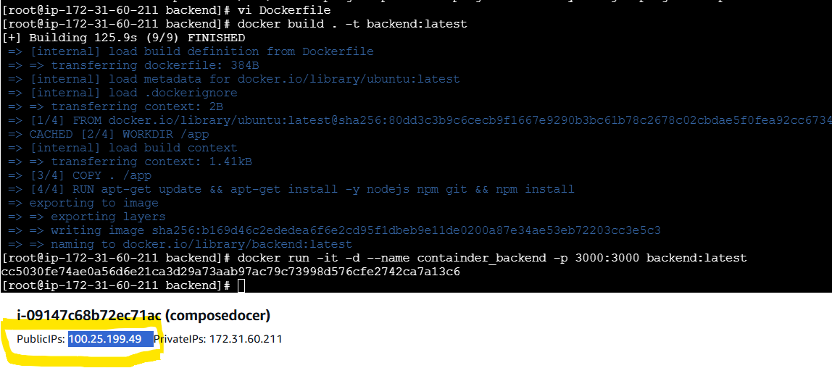

**8. Fire the public Ip with port :3000 /hello**

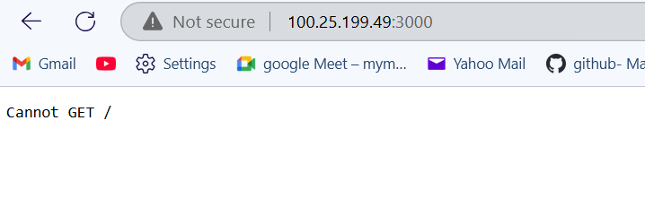

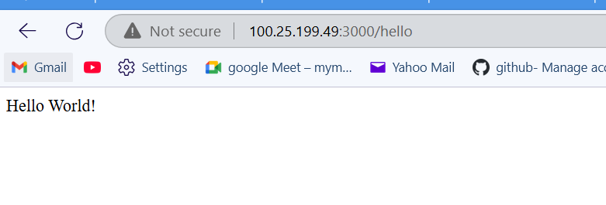

**List of commands used ;-**

* **yum update -y**
* **yum install docker**
* **systemctl start docker**
* **systemctl enable docker**
* **history**
* **git clone https://github.com/Kavi1312/TravelMemory.git**
* **yum install git**
* **git clone https://github.com/Kavi1312/TravelMemory.git**
* **cd TravelMemory/**
* **cd backend/**
* **ls**
* **vi Dockerfile**
* **ls**
* **docker build . -t backend:latest**
* **docker images**
* **docker run -it -d --name containder_backend -p 3000:3000 backend:latest**
* **Docker ps -a**